**Project Report**

**On**

**Toll Tax Management System**

**DECLARATION**

I hereby declare that, this is my own work and it has never been submitted to any institution of higher learning for any award. This explains why all citation there is dully acknowledged for in the reference section.

Signature ………………… Date……………....

(Student)

**INTRODUCTION:**

Toll Tax Management System is a web based application that can provide all the information related to toll plazas and the passenger checks in and pays the amount, then he/she will be provided by a receipt. With this receipt he/she can leave the toll booth without waiting for any verification call.

The information would also cover registration of staff, toll plaza collection, toll plaza collection entry for vehicles, date wise report entry, Vehicle passes and passes reports b/w dates.

**OBJECTIVE**

This project is based on the RDBMS technology. The main objective of this project is to computerize the manual system & reduce the time consumption.

In other words we can say that our project has the following objectives:

• Make all the system computerize

• Reduce time consumption

• Reduce error scope

• All system managements are automated

• Centralized database management

• Easy operations for operator of the system

• No paper work requirement

Here we are going to see some points regarding to purpose and scope behind choosing this topic & what is the requirement of this type of the project in our day to day life.

* Avoid the fuel loss.
* Saving of time in collecting toll.
* Avoid financial loss.
* To monitor the traffic.

**FEATURES OF THE APPLICATION**

Below listed is the broad category of the features for Toll Tax Department:

* This application is to facilitate the department in maintaining the repositories of the report about the toll tax collected at a specific time period.
* To provide details about contracts, contractors of Toll Tax Department
* To provide Toll Tax Rates of different vehicles.

**TECHNOLOGY**

**SOFTWARE OR TOOLS**

The tools that I have used in developing this System is:-

* Sublime, Notepad++
* Xamppserver
* Adobe Photoshop
* Google chrome,Firefox,Internet Explorer
* Bootstrap Framework
* Microsoft word for project documentation
* JQuery
* HTML
* PHP
* MYSQL

**HARDWARE REQUIREMENTS**

1. Personal computer with at least

* At least 4GB of RAM
* At least Hard disk (300GB, 500GB .etc.)
* At least Processor 2.7GHZ

1. Printer

**PROJECT OVERVIEW**

It has two modules admin and staff.

**Admin**

1. **Dashboard:** In this section admin can see all detail in brief like total number of staffs, Total number of vehicle category, Total number of pass, Total number of receipt, Total vehicle enter today’s, yesterday’s, last seven days and total vehicle pass till now in toll plaza.
2. **Staff:** In this section admin can manage staffs (add and update).
3. Vehicle Category: In this section admin can manage vehicle category (add and update).
4. **Pass:** In this section admin can manage pass(add and update).
5. **Receipt:** In this section admin can view receipt and take print of receipt which is make by staffs
6. **Search Pass:** In this section admin can search pass with the help of his/her pass id, owner name and vehicle number.
7. **Search Receipt:** In this section admin can search receipt with the help of his/her receipt id, owner name and vehicle number.
8. **Reports of Pass:** In this section admin can view how many pass has been made in particular periods, counts of pass and sales come from making pass.
9. **Reports of receipt:** In this section admin can view how much receipt has been made in particular periods, counts of receipt and sales come from making receipt.

Admin can also update his profile, change password and recover password.

**Staffs**

1. **Dashboard:** Welcome page for staff.
2. **Receipt:** In this section staff can mange receipts (add and update).
3. **Search:** In this section admin can search receipt with the help of his/her receipt id.

Staffs can also update his profile, change password and recover password.

**SYSTEM DEVELOPMENT ENVIRONMENT**

**1. HTML**

**WHAT IS HTML?**

To publish information for global distribution, one needs a university-understood language, a kind of publishing mother tongue that all computers may potentially understand. The publishing language used by the World Wide Web is HTML (Hyper Text Markup Language)

**HTML Gives Authors the Means To**

1. Publish online documents with headings, text, tables, list, photos etc.
2. Retrieve online information via hypertext links, at the click of a button
3. Design forms for conducting transactions with remote services, for use in searching information, making reservation, ordering products etc.;
4. Includes spreadsheets, video clips, sound clips, and other applications directly in the documents.

**Some HTML Tags**

<HTML> :Starting an HTML tag

<HEAD> : Creating a web page’s head

<TITLE> : Giving a web page ‘s body

</HEAD> : Ending a web pages head

</BODY> : Ending a web pages body

</HTML> :Ending a web page

<FORM> : Creating a HTML forms

<INPUT TYPE=BUTTON> : Creating a buttons

<INPUT TYPE=CHECKBOX> : Creating a checkboxes

<INPUT TYPE=SUBMIT> : Creating a submit button

<INPUT TYPE=TEXT> : Creating a text fields

**HTML 4.0**

HTML 4.0 extends with mechanisms for style sheets, scripting, frames embedding objects, improved support for right to left and mixed direction texts, richer tables and enhancements to form, offering improved accessibilities for people with disability.

**2. INTRODUCTION TO JAVA SCRIPT**

**WHAT IS JAVA SCRIPT?**

JavaScript, originally supported by Netscape Navigator, is the most popular Web scripting language today. JavaScript lets you embed programs right in your Web pages and run these programs using the Web browser. You place these programs in a <SCRIPT> element. If you want the script to write directly to the Web page, place it in the <BODY> element.

**EX:** <HTML>

<HEAD>

<TITLE></TITLE>

</HEAD>

<BODY>

<SCRIPT LANGUAGE=”JavaScript”>

</SCRIPT>

</BODY></HTML>

**JAVASCRIPTS OBJECTS**

JavaScript is an object-oriented language. JavaScript comes with a number of predefined objects.

**Objects of the JavaScript**

1. Document: Corresponds to the current Web page’s body. Using this object, you have access to the HTML of the page itself, including the all links, images and anchors in it.
2. Form: Holds information about HTML forms in the current page.
3. Frame: Refers to a frame in the browser’s window.
4. History: Holds the records of sites the Web browser has visited before reaching the current page.
5. Location: Holds information about the location of the current web page.
6. Navigator: Refers to the browser itself, letting you determine what browser the user has.
7. Window: Refers to the current browser window.

**JAVASCRIPTS EVENTS**

Some of the events of JavaScript

1. on Change: Occurs when data in a control, like a text field, changes.
2. on Click: Occurs when an element is clicked.
3. on Focus: Occurs when an element gets the focus.
4. on Mouse Down: Occurs when a mouse button goes down.
5. on Reset: Occurs when the user clicks the reset button.

**JAVASCRIPTS FUNCTIONS**

**Declaration of function**

Syntax: function function name ()

{

…

…

}

Write these functions in <SCRIPT> tag.

**RDBMS CONCEPTS**

1. **DATA ABSTRACTION**

A major purpose of a database system is to provide users with an abstract view of the data. This system hides certain details of how the data is stored and maintained. However in order for the system to be usable, data must be retrieved efficiently. The efficiency lead to the design of complex data structure for the representation of data in the database. Certain complexity must be hidden from the database system users. This accomplished by defining several levels of abstraction at which the database may be viewed.

1. **CLASSIFICATION OF DATABASE**

There are 3 types of database approaches given below,

* 1. **Hierarchical Database:**

In this type of model data is represented in simple tree structured. The record at the top of three is known as root, the root may have any number of dependents. Each of these may have any number of low level dependents and so on up to any number of levels. The disadvantages of the approach are that no independent record occurrence can exist without it’s superior.

* 1. **Network Database:**

In a Network database, data is represented by Network structure. In this approach record occurrence can have any number of superiors as well as any number of immediate dependents thus allow many to many correspondence directly than an hierarchical approach. The main disadvantage of the Network model is data representation is very complex resulting in complexity of the DML (Data Manipulation Language).

* 1. **Relational Database:**

The Relational model represents data and relationships among data by a collection of tables each of which has a number of columns with unique names.

**THE SQL LANGUAGE**

SQL is a language for relational database. SQL is a non-procedural i.e., when we use SQL we specify what we want to be done not how to do it.

**Features of SQL**

1. SQL is an interactive query language.
2. SQL is a database administration language.
3. SQL is a database programming language.
4. SQL is a client/server language.
5. SQL is a distributed database language.
6. SQL is a database gateway language.

**Basic SQL Commands**

* Data Definition Language commands (DDL)
* Data Manipulation Language commands (DML)
* Transaction Control Language commands (TCL)
* Data control Language commands (DCL)

**PHP**

* PHP is an acronym for "PHP: Hypertext Preprocessor"
* PHP is a widely-used, open source scripting language
* PHP scripts are executed on the server
* PHP is free to download and use

## What is a PHP File?

* PHP files can contain text, HTML, CSS, JavaScript, and PHP code
* PHP code are executed on the server, and the result is returned to the browser as plain HTML
* PHP files have extension ".php"

## What Can PHP Do?

* PHP can generate dynamic page content
* PHP can create, open, read, write, delete, and close files on the server
* PHP can collect form data
* PHP can send and receive cookies
* PHP can add, delete, modify data in your database
* PHP can be used to control user-access
* PHP can encrypt data

With PHP you are not limited to output HTML. You can output images, PDF files, and even Flash movies. You can also output any text, such as XHTML and XML.

**DESIGN DOCUMENT**

* + The entire system is projected with a physical diagram which specifics the actual storage parameters that are physically necessary for any database to be stored on to the disk. The overall systems existential idea is derived from this diagram.
  + The relation upon the system is structure through a conceptual ER-Diagram, which not only specifics the existential entities but also the standard relations through which the system exists and the cardinalities that are necessary for the system state to continue.
  + The content level DFD is provided to have an idea of the functional inputs and outputs that are achieved through the system. The system depicts the input and output standards at the high level of the systems existence.

A DFD does not show a sequence of steps. A DFD only shows what the different process in a system is and what data flows between them.

The following are some DFD symbols used in the project

External entities

Process: A transaction of information that resides within the bounds of the system to be module.

DATAFLOWS

DATASTORE: A repository of data that is to be stored for use by one or more processes, may be as simple as buffer of queue or as a relational database.

**RULES FOR DFD:**

* Fix the scope of the system by means of context diagrams.
* Organize the DFD so that the main sequence of the actions reads left to right and top to bottom.
* Identify all inputs and outputs.
* Identify and label each process internal to the system with rounded circles.
* A process is required for all the data transformation and transfers. Therefore, never connect a data store to a data source or the destinations or another data store with just a data flow arrow.
* Do not indicate hardware and ignore control information.
* Make sure the names of the processes accurately convey everything the process is done.
* There must not be unnamed process.
* Indicate external sources and destinations of the data, with squares.
* Number each occurrence of repeated external entities.
* Identify all data flows for each process step, except simple Record retrievals.
* Label data flow on each arrow.
* Use details flow on each arrow.
* Use the details flow arrow to indicate data movements.
* There can’t be unnamed data flow.
* A data flow can’t connect two external entities.

**LEVELS OF DFD:**

The complexity of the business system means that it is a responsible to represent the operations of any system of single data flow diagram. At the top level, an Overview of the different systems in an organization is shown by the way of context analysis diagram. When exploded into DFD

They are represented by:

* LEVEL-0 : SYSTEM INPUT/OUTPUT
* LEVEL-1:SUBSYSTEM LEVEL DATAFLOW FUNCTIONAL
* LEVEL-2: FILE LEVEL DETAIL DATA FLOW.

The input and output data shown should be consistent from one level to the next.

**LEVEL-0: SYSTEM INPUT/OUTPUT LEVEL**

A level-0 DFD describes the system-wide boundaries, dealing inputs to and outputs from the system and major processes. This diagram is similar to the combined user-level context diagram.

**LEVEL-1: SUBSYSTEM LEVEL DATA FLOW**

A level-1 DFD describes the next level of details within the system, detailing the data flows between subsystems, which makeup the whole.

**0 Level Diagram**

Staff

Administrator

**1st Level DFD**

Administrator

Administrator

**2. Unified Modeling Language Diagrams(UML):**

* + The unified modeling language allows the software engineer to express an analysis model using the modeling notation that is governed by a set of syntactic semantic and pragmatic rules.
  + A UML system is represented using five different views that describe the system from distinctly different perspective. Each view is defined by a set of diagram, which is as follows.

**User Model View**

* + 1. This view represents the system from the users perspective.
    2. The analysis representation describes a usage scenario from the end-users perspective**.**

**Structural model view**

◆In this model the data and functionality are arrived from inside the system.

◆ This model view models the static structures.

**Behavioral Model View**

◆ It represents the dynamic of behavioral as parts of the system, depicting the interactions of collection between various structural elements described in the user model and structural model view.

**Implementation Model View**

* + In this the structural and behavioral as parts of the system are represented as they are to be built.

**Environmental Model View**

In this the structural and behavioral aspects of the environment in which the system is to be implemented are represented.

UML is specifically constructed through two different domains they are

* + UML Analysis modeling, which focuses on the user model and structural model views of the system?
  + UML design modeling, which focuses on the behavioral modeling, implementation modeling and environmental model views**.**

### Use Case Diagrams Admin

### Use Case Diagrams Staff

#### ENTITY-RELATIONSHIP Diagrams

E-R (Entity-Relationship) Diagram is used to represents the relationship between entities in the table.

## The symbols used in E-R diagrams are:

SYMBOL PURPOSE

Represents Entity sets.

Represent attributes.

Represent Relationship Sets.

Line represents flow

Structured analysis is a set of tools and techniques that the analyst.

To develop a new kind of a system:

The traditional approach focuses on the cost benefit and feasibility analysis, Project management, and hardware and software selection a personal considerations.

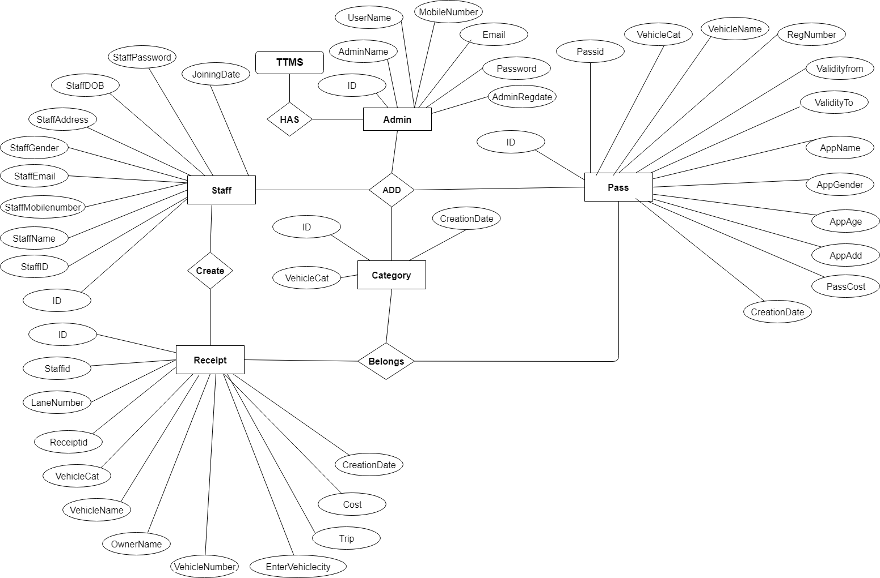

**DATABASE DESIGN**

The data in the system has to be stored and retrieved from database. Designing the database is part of system design. Data elements and data structures to be stored have been identified at analysis stage. They are structured and put together to design the data storage and retrieval system.

A database is a collection of interrelated data stored with minimum redundancy to serve many users quickly and efficiently. The general objective is to make database access easy, quick, inexpensive and flexible for the user. Relationships are established between the data items and unnecessary data items are removed. Normalization is done to get an internal consistency of data and to have minimum redundancy and maximum stability. This ensures minimizing data storage required, minimizing chances of data inconsistencies and optimizing for updates. The MS Access database has been chosen for developing the relevant databases.

**Toll Tax Management System (ttms) contains 5 MySQL tables:**

**tbladmin table Structure :** This table store the login details of admin.

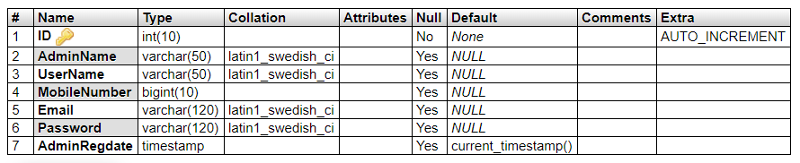

**tblstaff table Structure :** This tables stores the staff personal and login details.

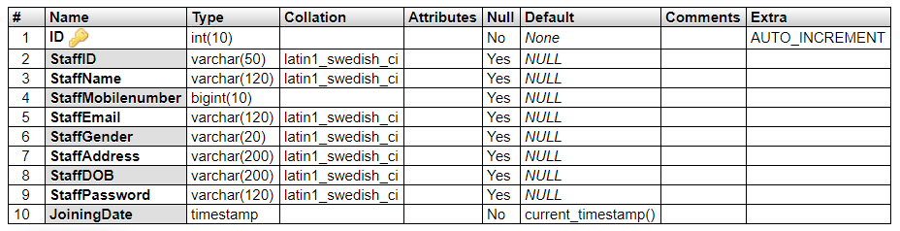

**tblcategory table Structure :** This tables stores the vehicle category details.

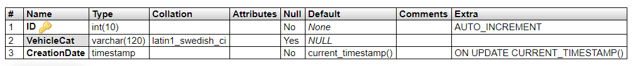

**tblreceipt table Structure :** This tables stores the vehicle toll receipt details(like vehicle number, owner details).

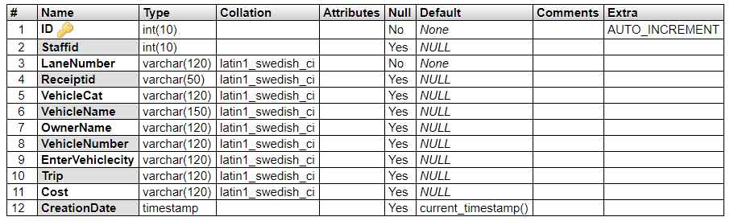

**tblpass table Structure :** This tables stores the vehicle toll pass.

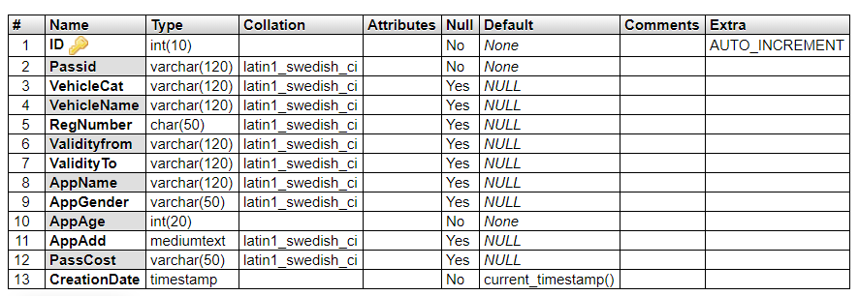

**Class Diagram:**

The class diagram shows a set of classes, interfaces, collaborations and their relationships.

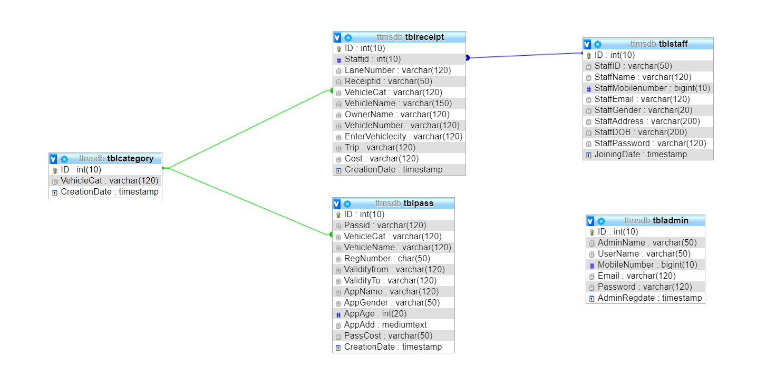

**SYSTEM TESTING**

**SOFTWARE TESTING TECHNIQUES:**

Software testing is a critical element of software quality assurance and represents the ultimate review of specification, designing and coding.

**TESTING OBJECTIVES:**

1. Testing is process of executing a program with the intent of finding an error.
2. A good test case design is one that has a probability of finding an as yet undiscovered error.
3. A successful test is one that uncovers an as yet undiscovered error.

These above objectives imply a dramatic change in view port.

Testing cannot show the absence of defects, it can only show that software errors are present.

There are three types of testing strategies

1. Unit test
2. Integration test

3. Performance test

**Unit Testing:**

Unit testing focuses verification efforts on the smallest unit of software design module. The unit test is always white box oriented. The tests that occur as part of unit testing are testing the module interface, examining the local data structures, testing the boundary conditions, execution all the independent paths and testing error-handling paths.

**Integration Testing:**

Integration testing is a systematic technique or construction the program structure while at the same time conducting tests to uncover errors associated with interfacing. Scope of testing summarizes the specific functional, performance, and internal design characteristics that are to be tested. It employs top-down testing and bottom-up testing methods for this case.

**Performance Testing:**

Timing for both read and update transactions should be gathered to determine whether system functions are being performed in an acceptable timeframe.

**OUTPUT SCREEN**

**Home Page**

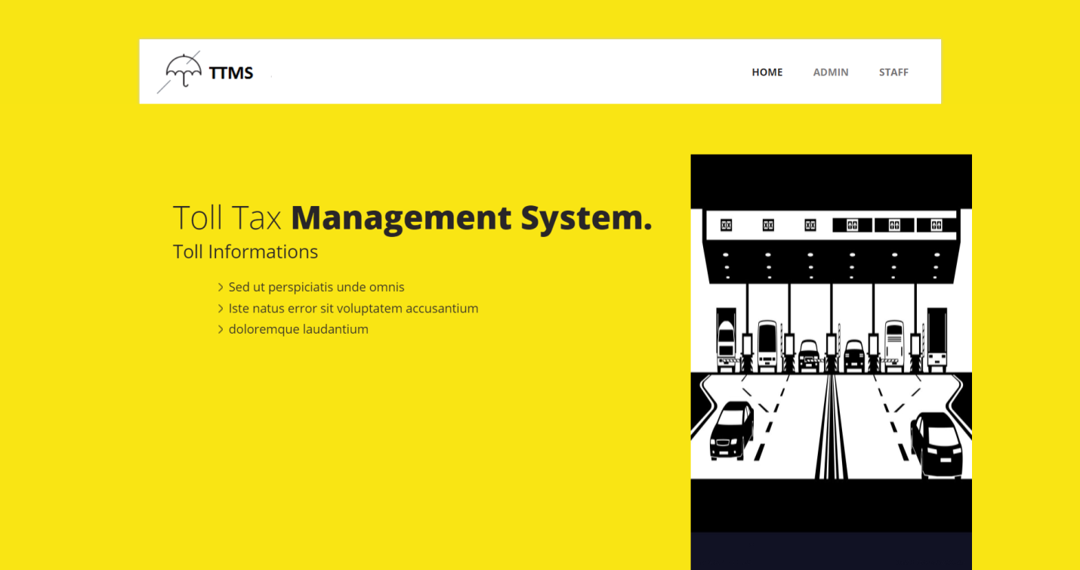

**Admin Login**

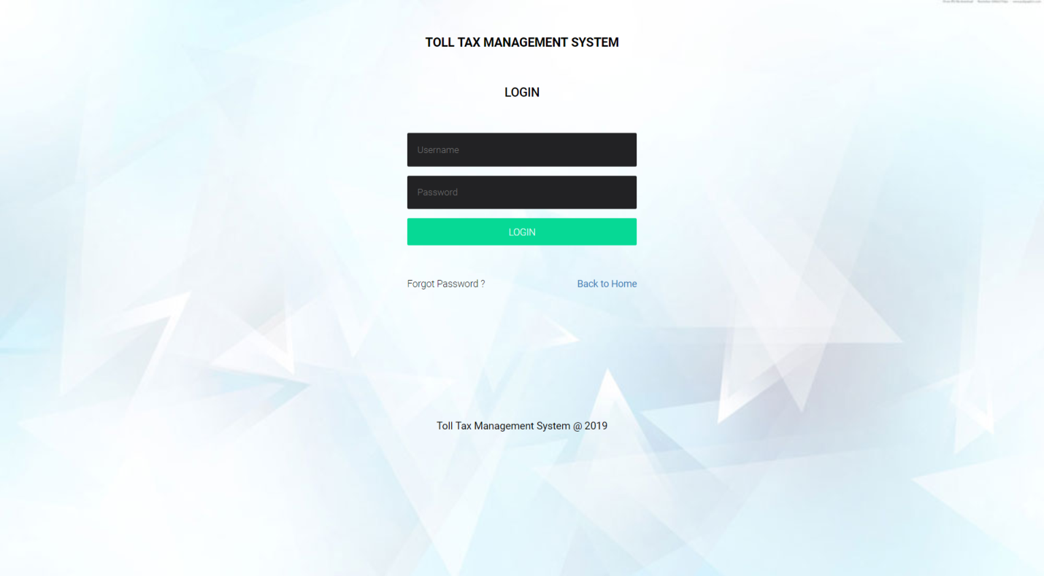

**Dashboard**

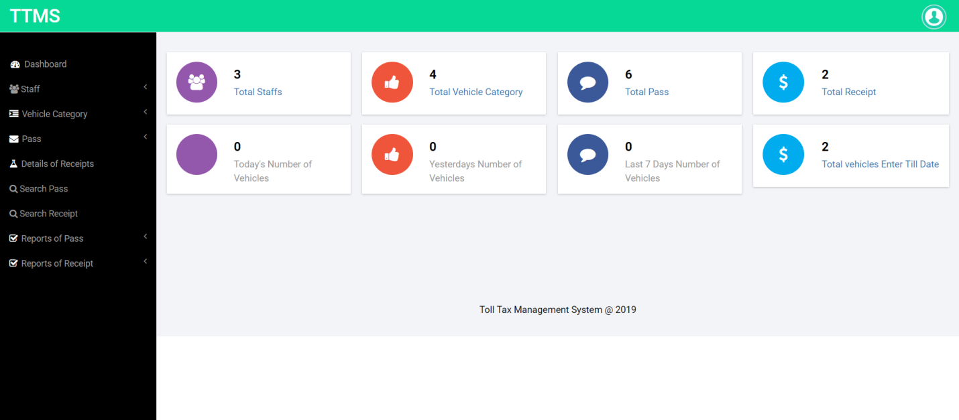

**Add Staff**

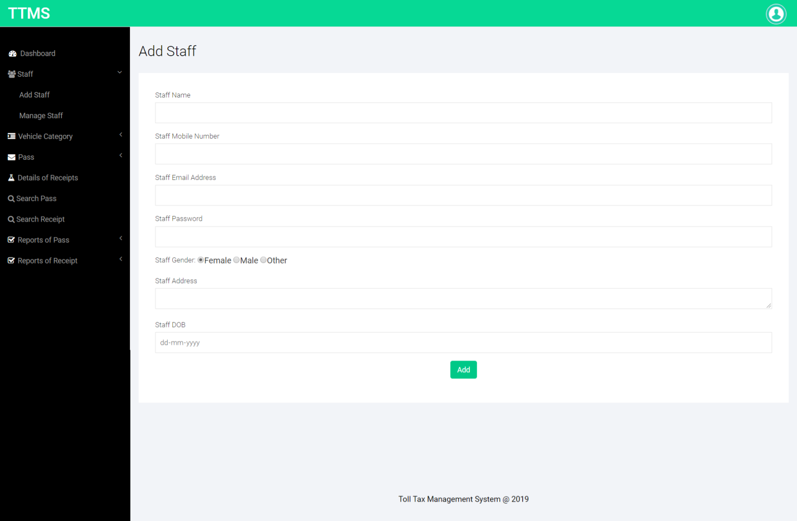

**Manage Staff**

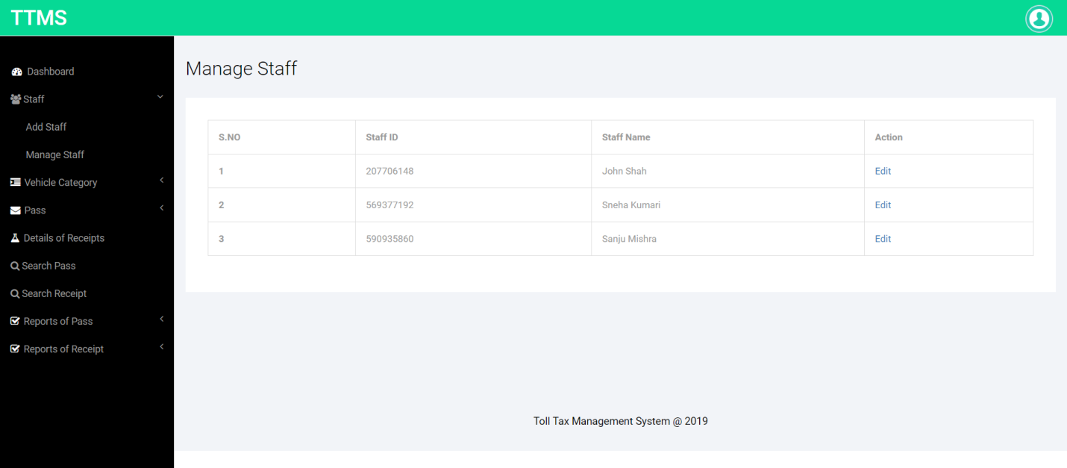

**Update Staff Information**

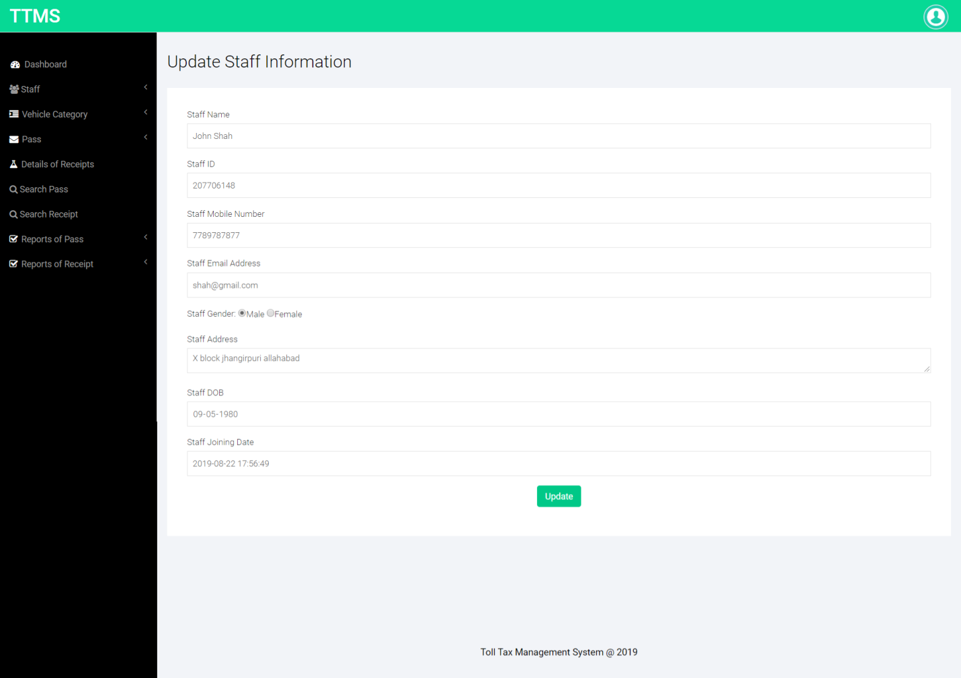

**Add Vehicle Category**

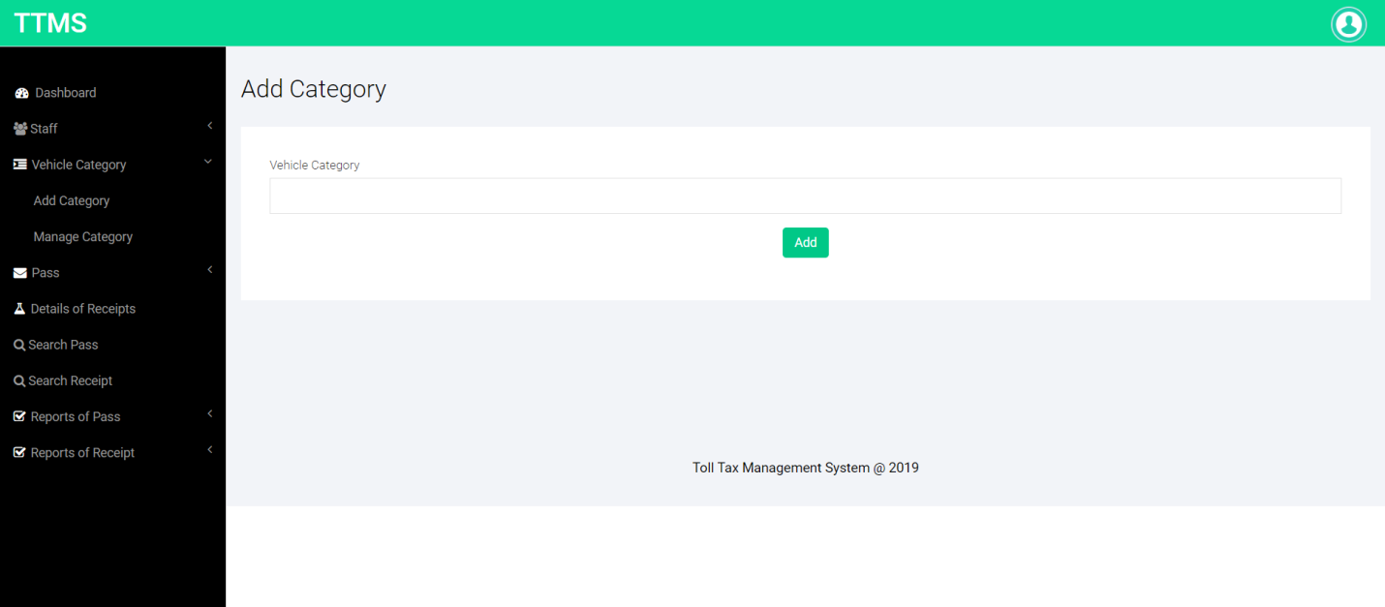

**Manage Category**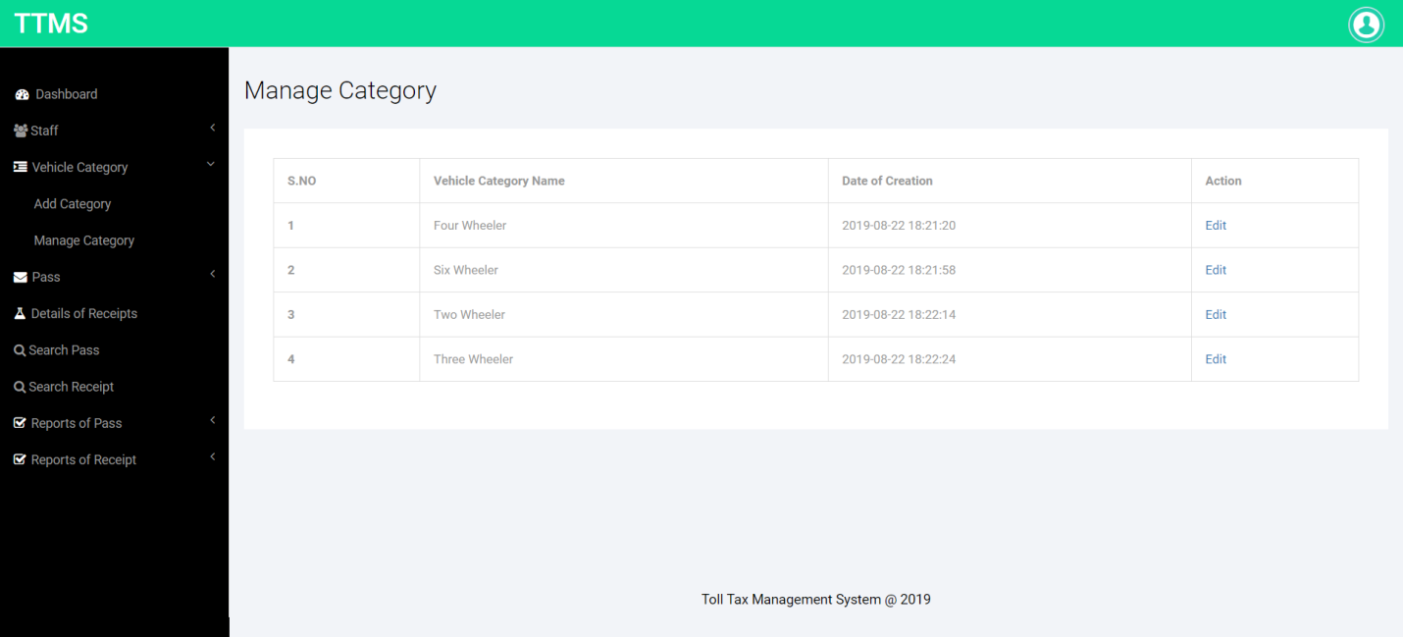

**Update Category**

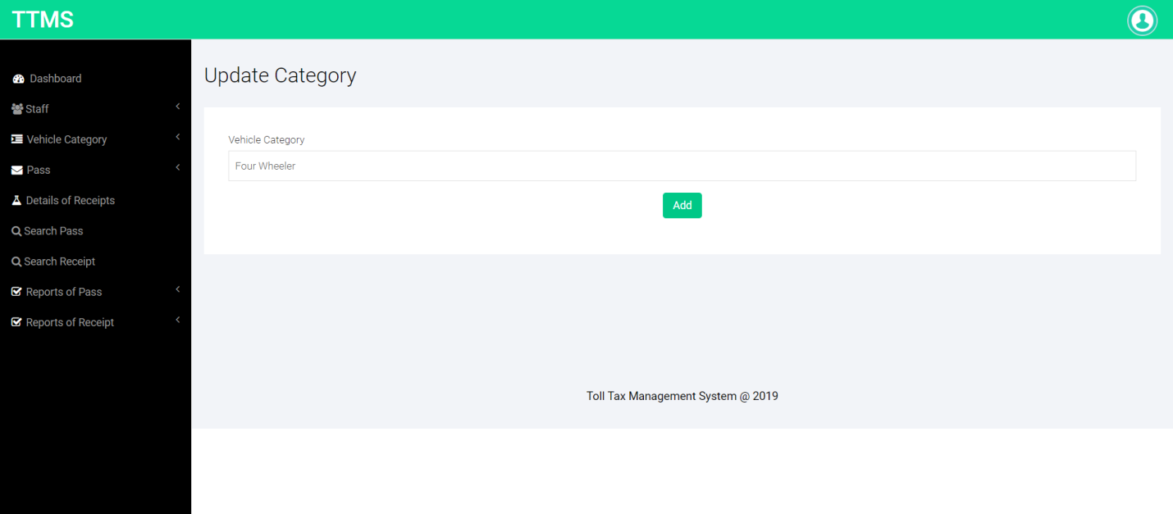

**Add New Pass**

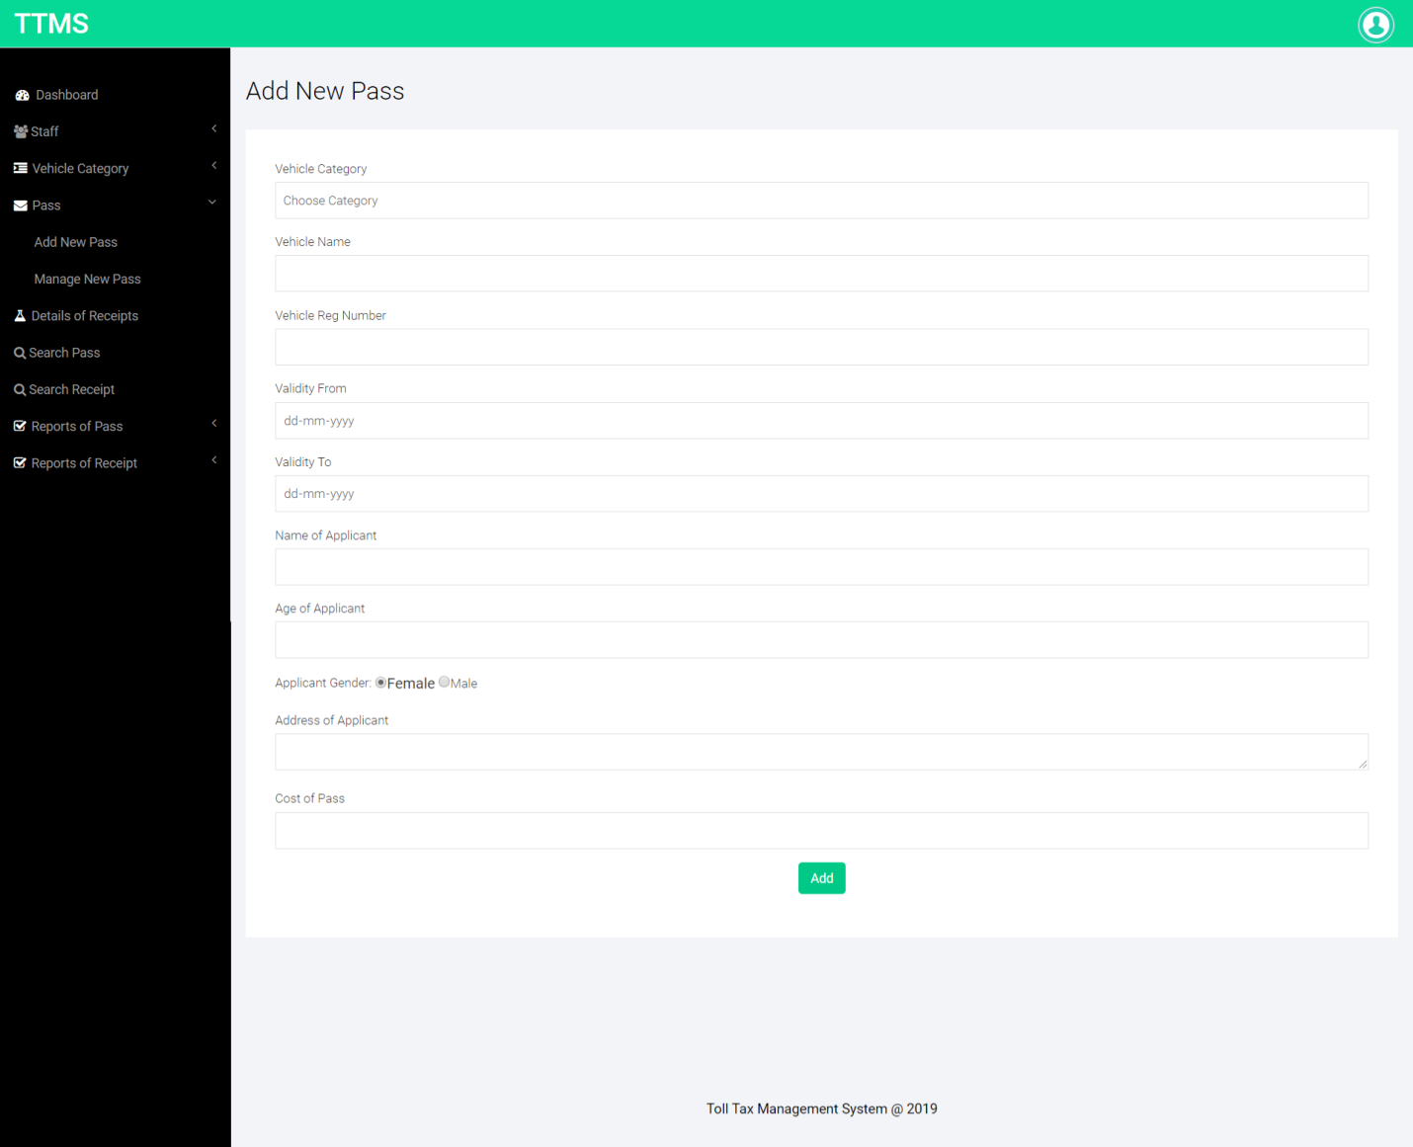

**Manage Pass**

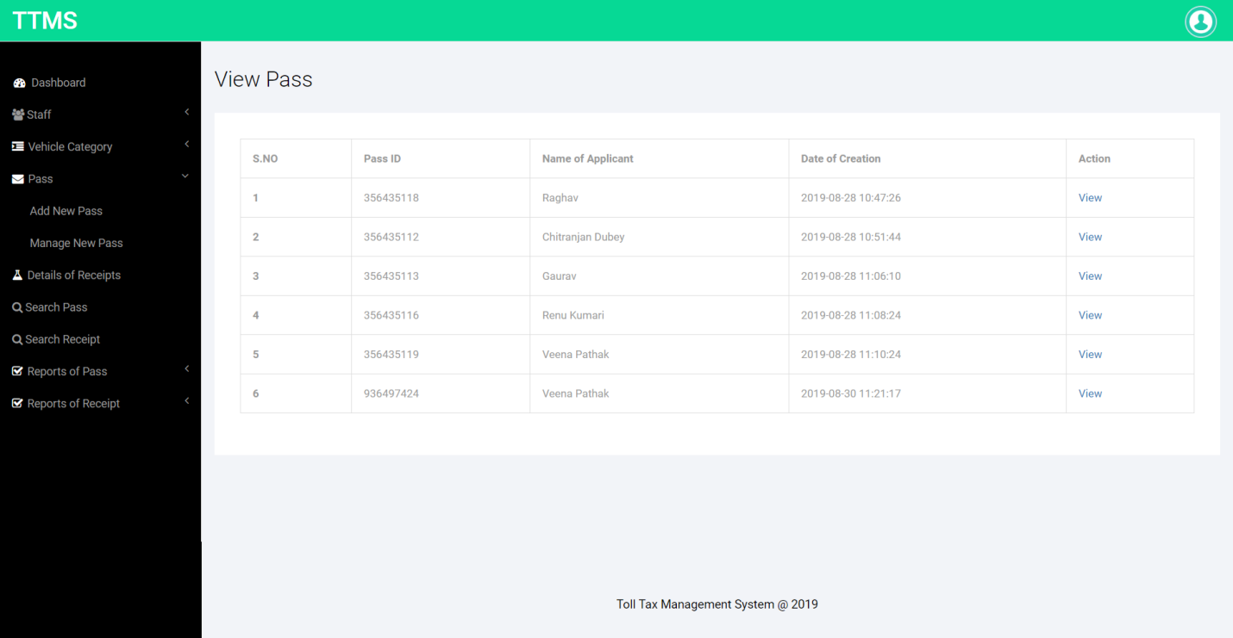

**Print Pass**

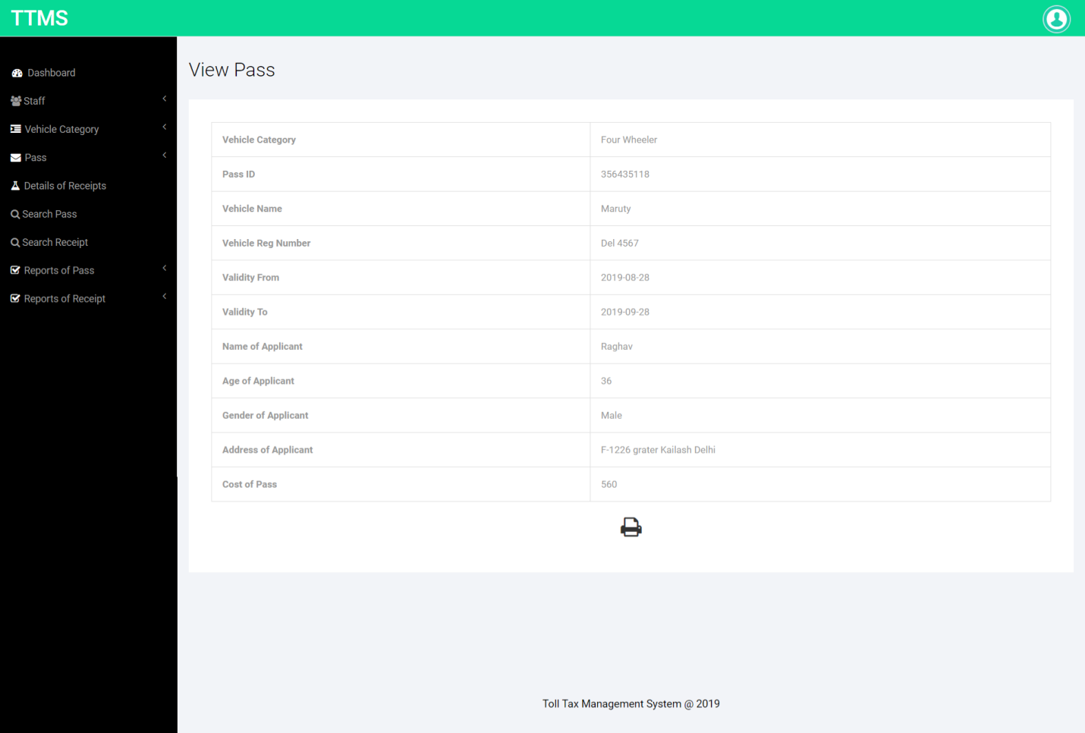

**View Receipt**

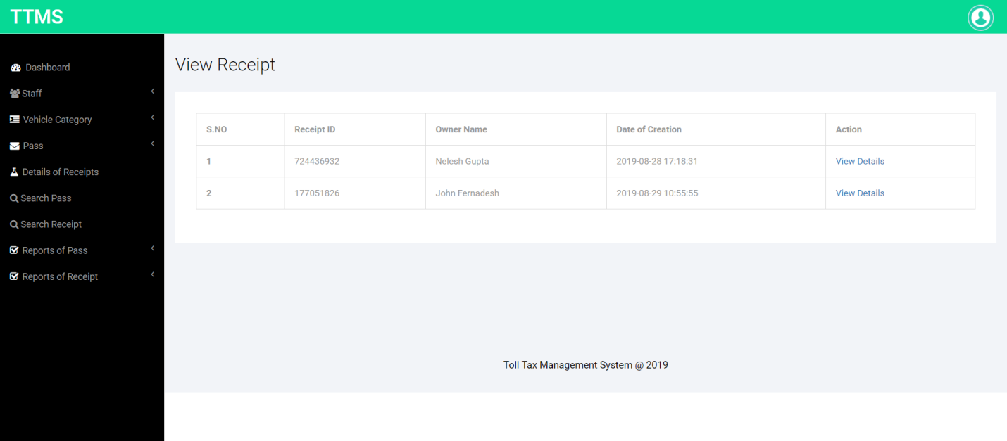

**Print Receipt**

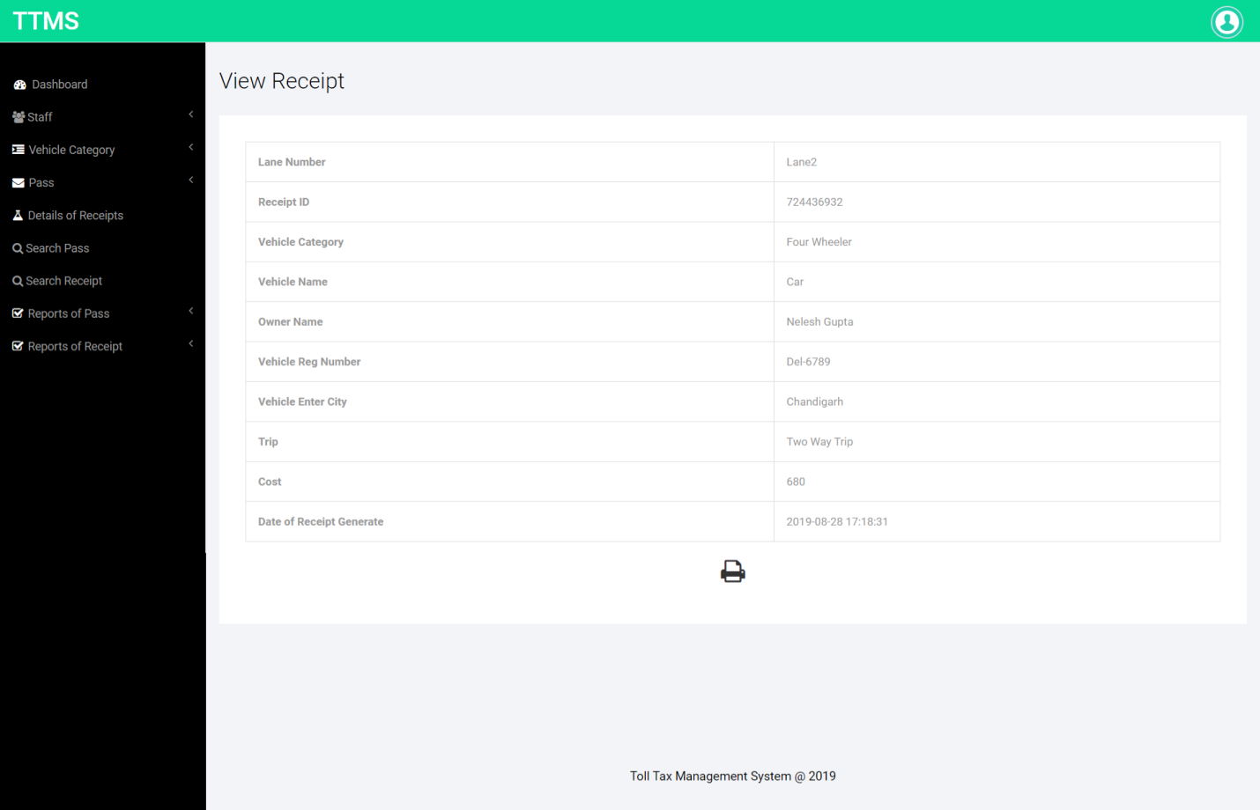

**Search Pass**

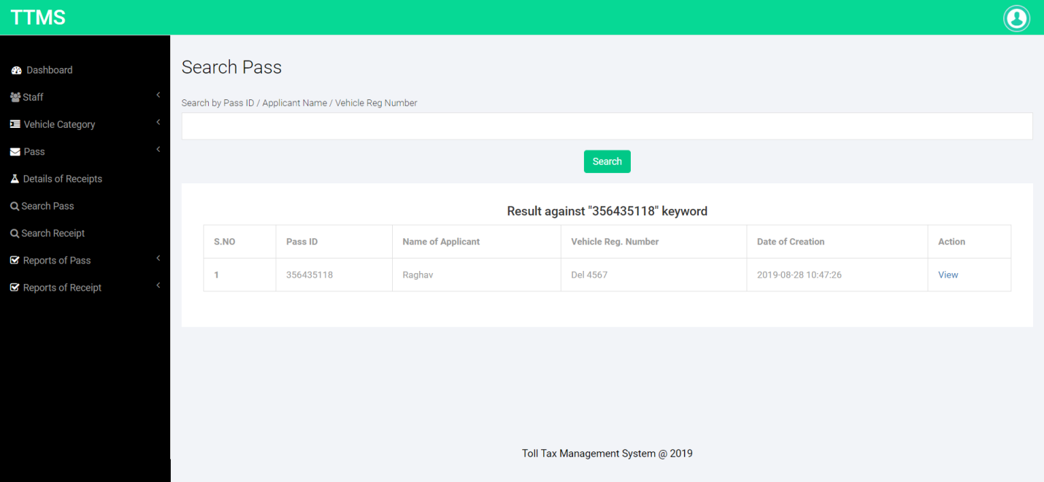

**Search Receipt**

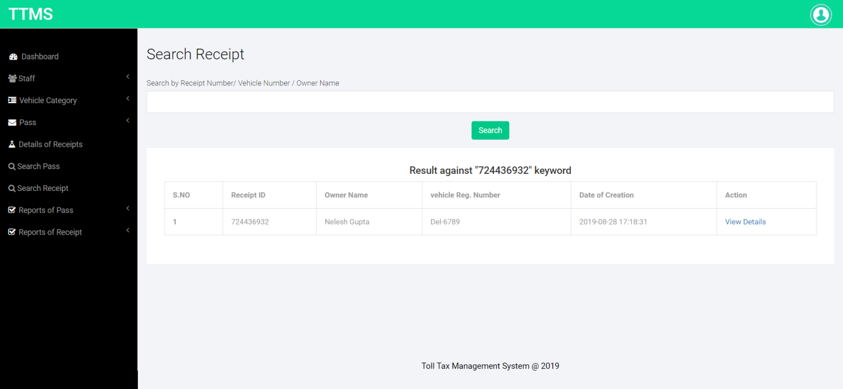

**B/W dates Reports**

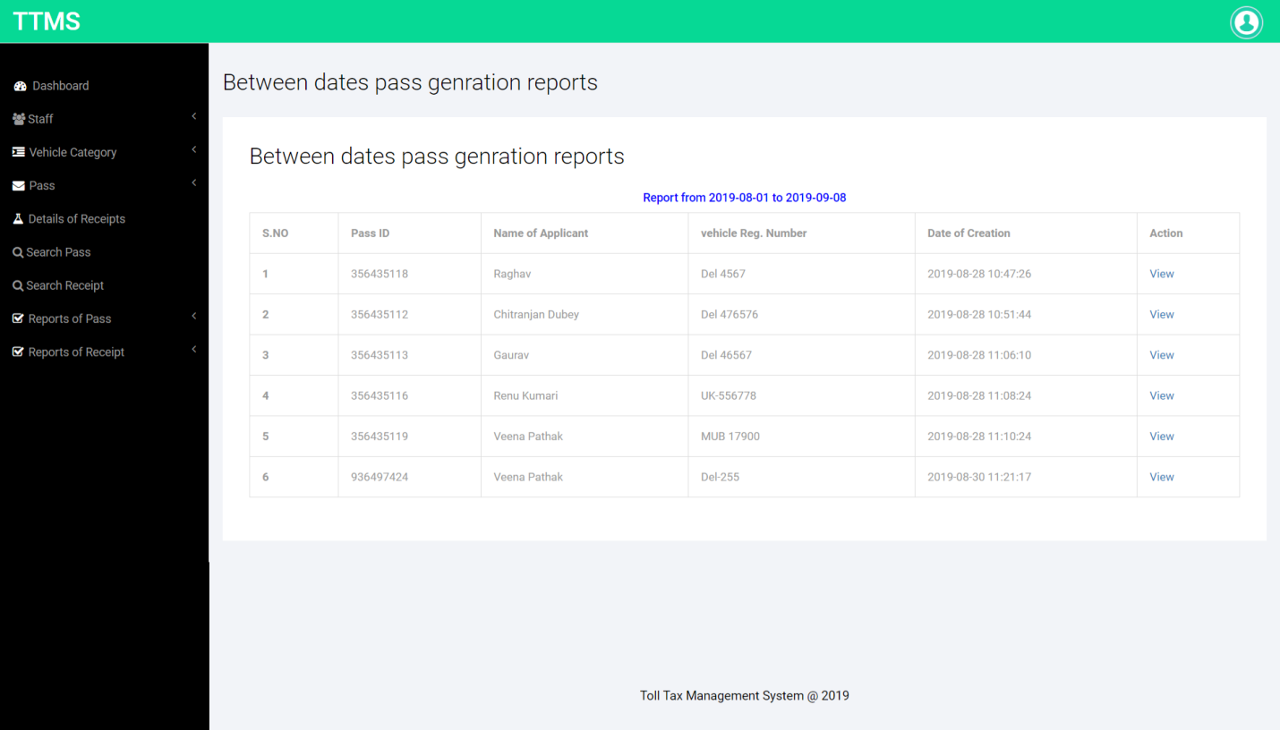

**Pass Count Reports**

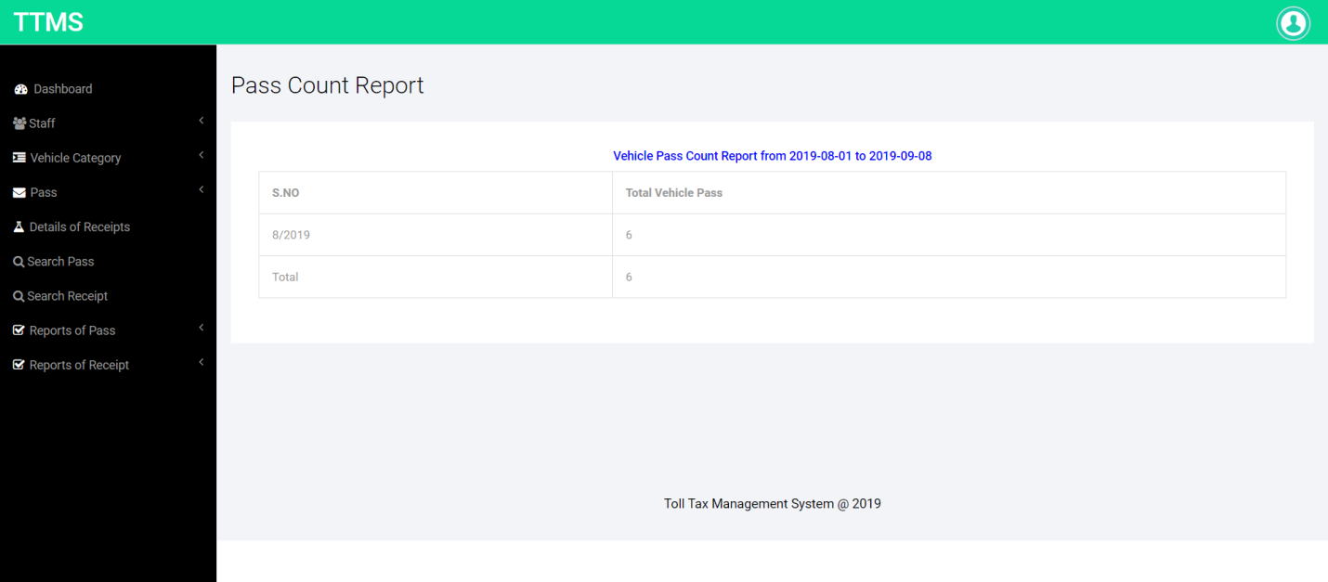

**Pass Sales Reports**

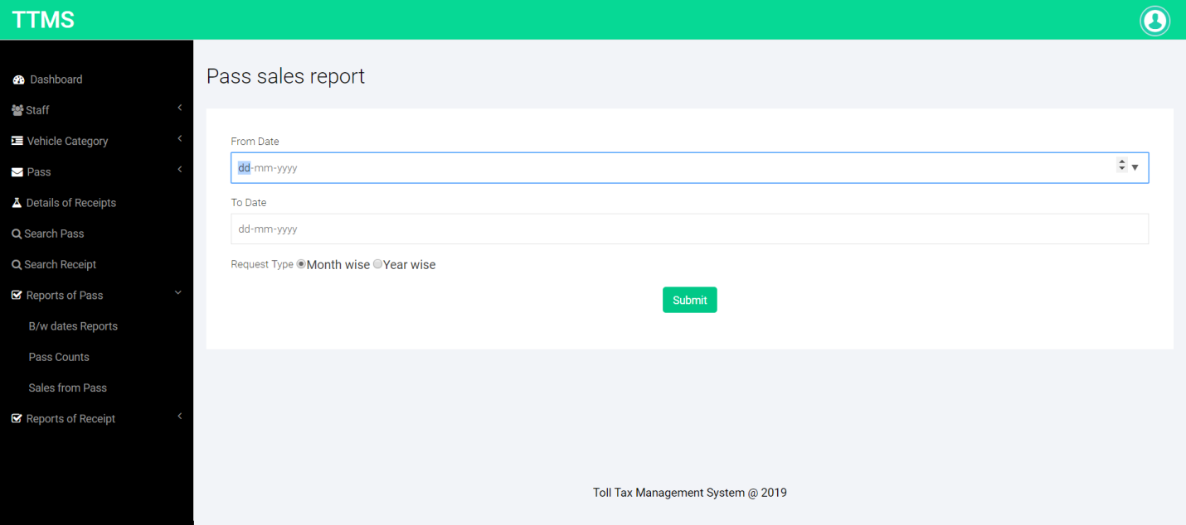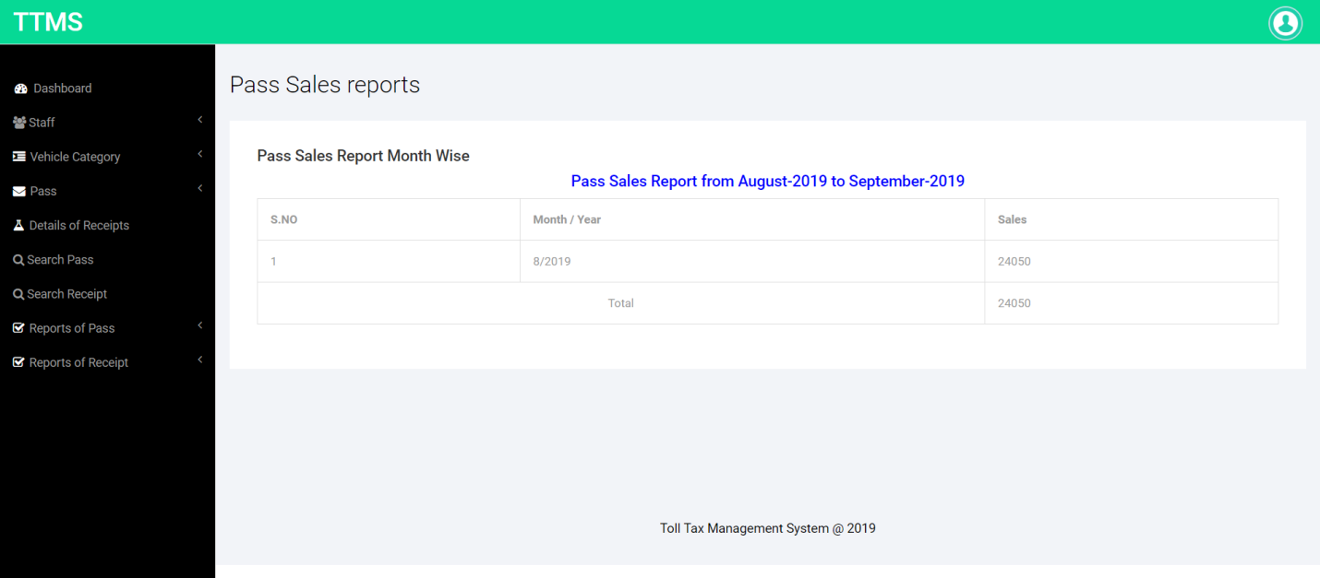

**B/w dates Receipt Reports**

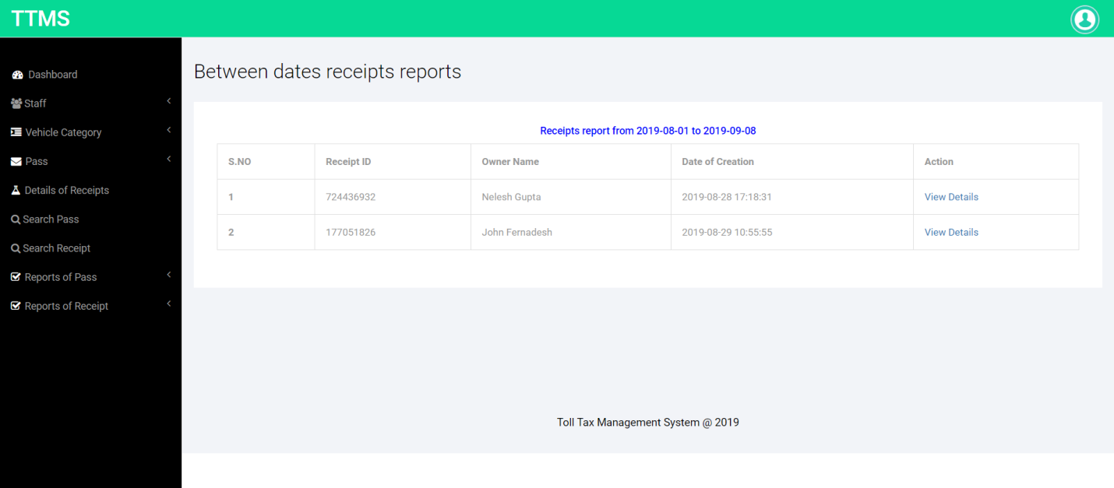

**Receipt Counts Reports**

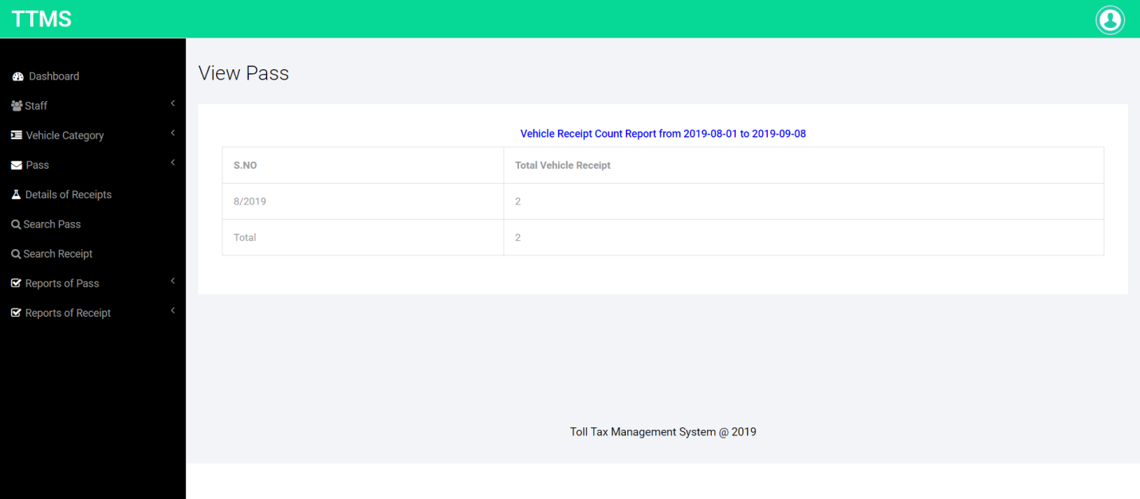

**Receipt Sales Reports**

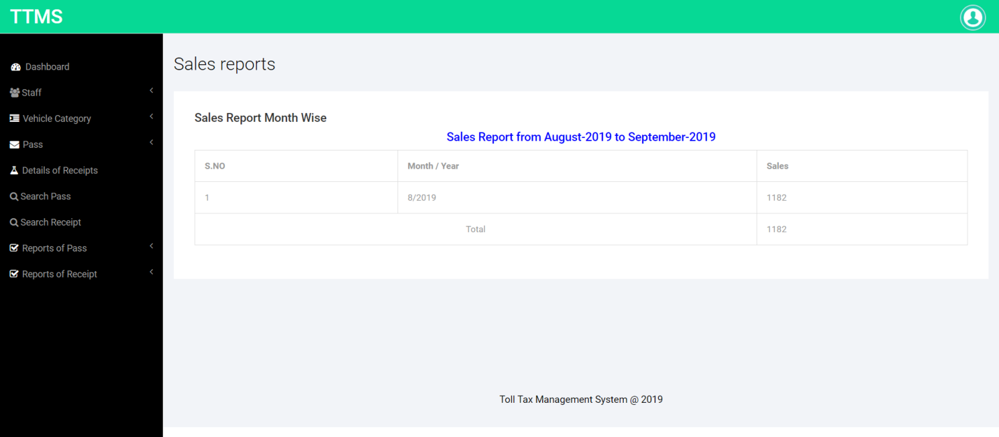

**Admin Profile**

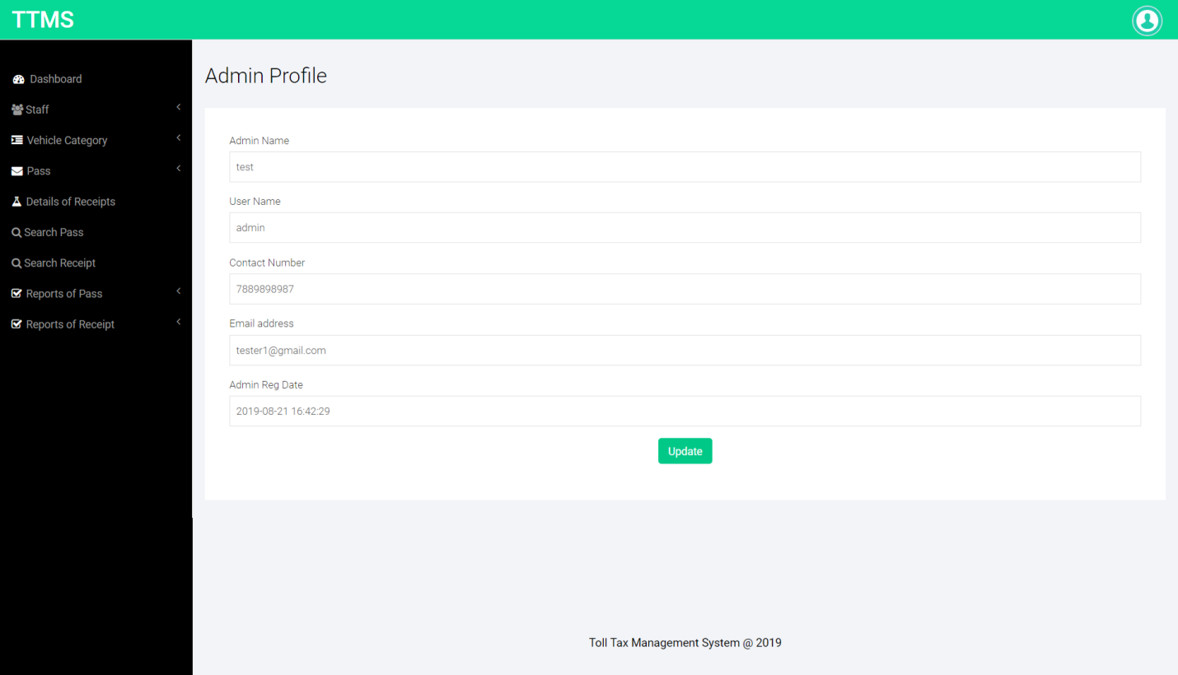

**Change Password**

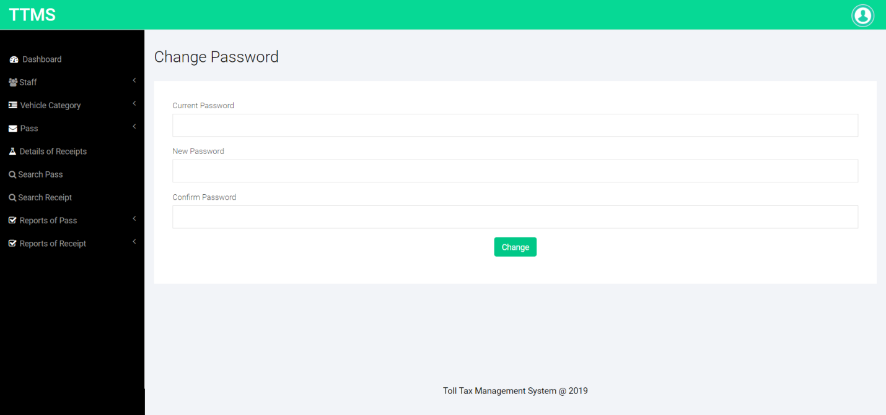

**Forgot Password**

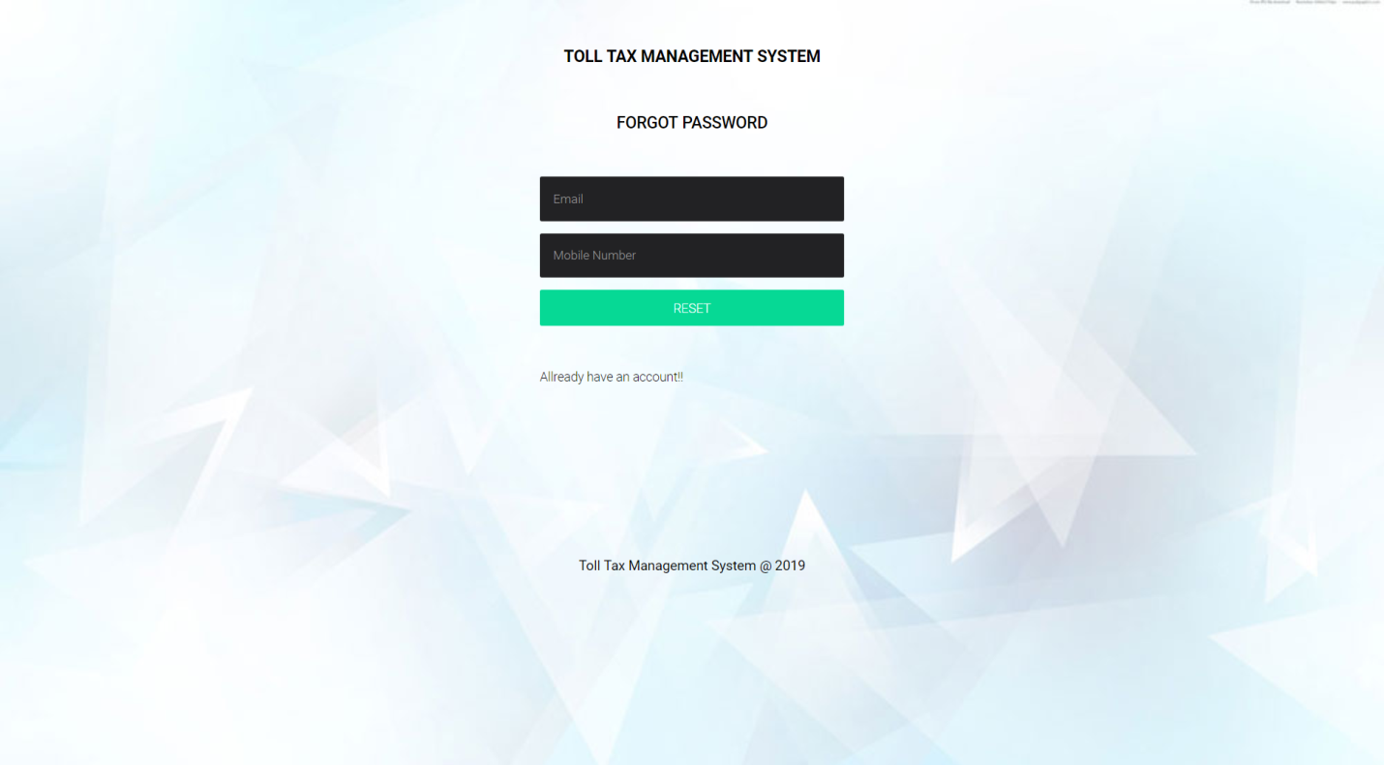

**Reset Password**

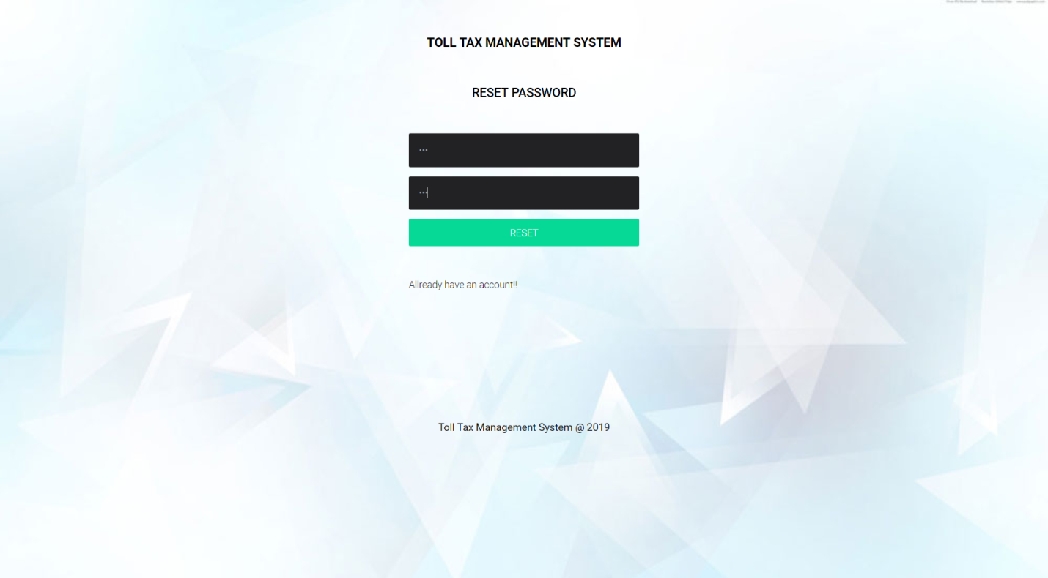

**Staff Login**

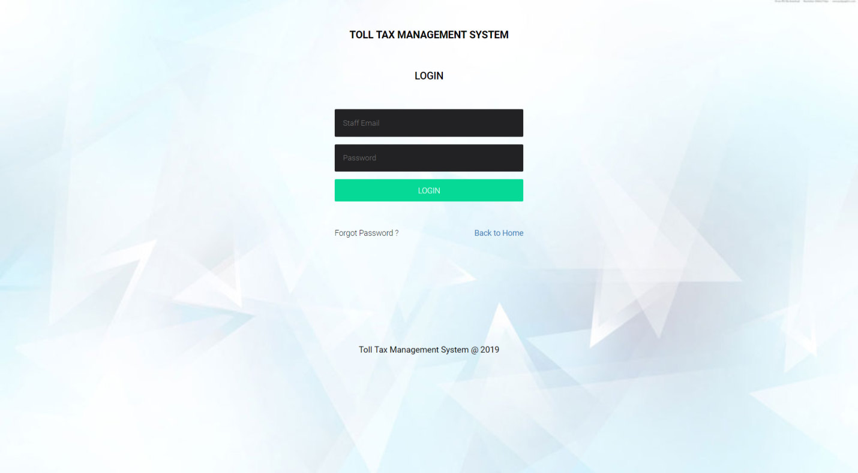

**Staff Dashboard**

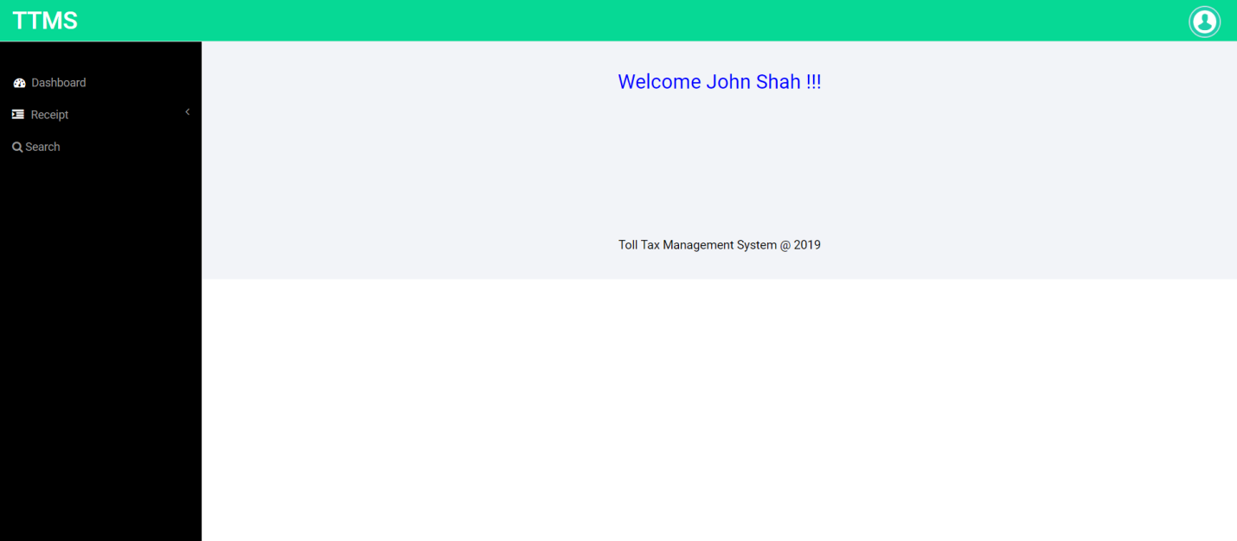

**Add Receipt**

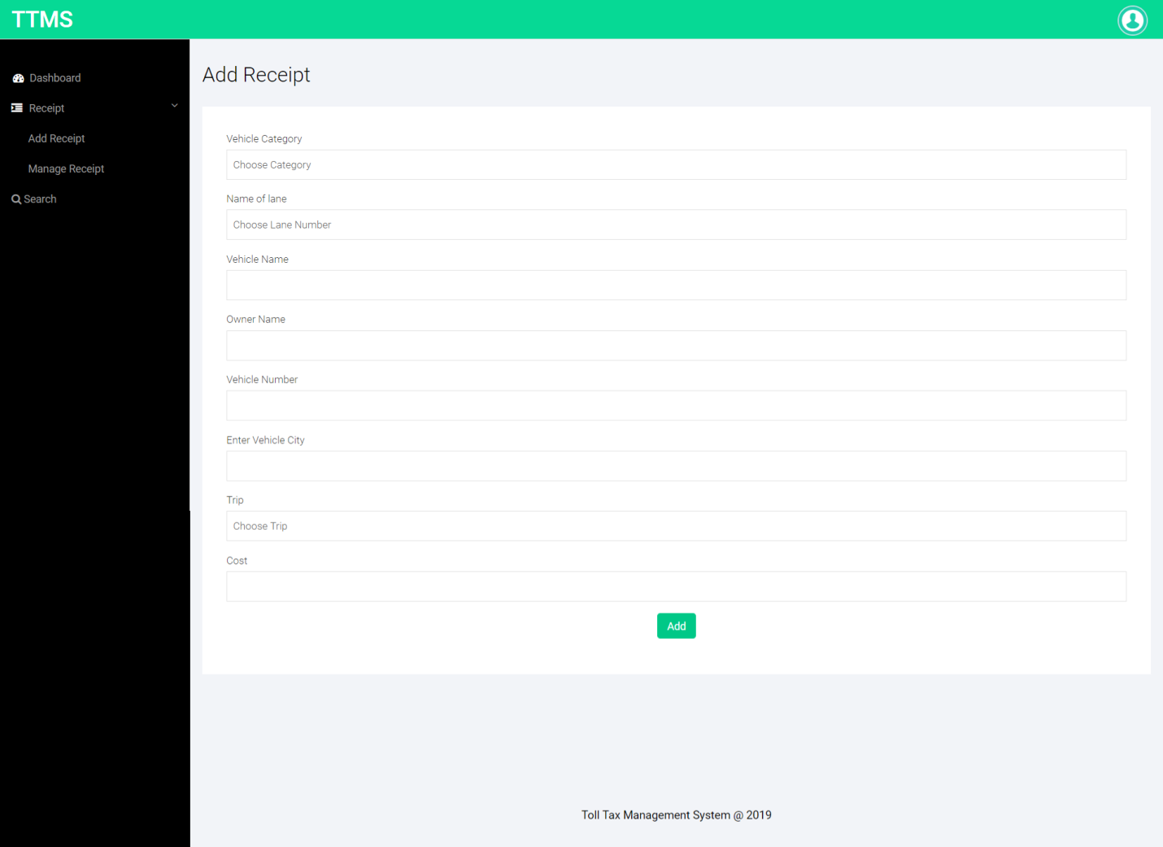

**Manage Receipt**

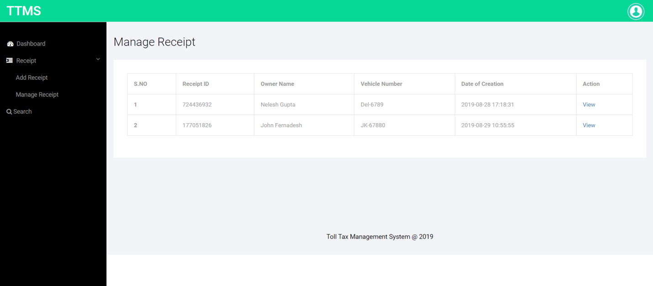

**Print Receipt**

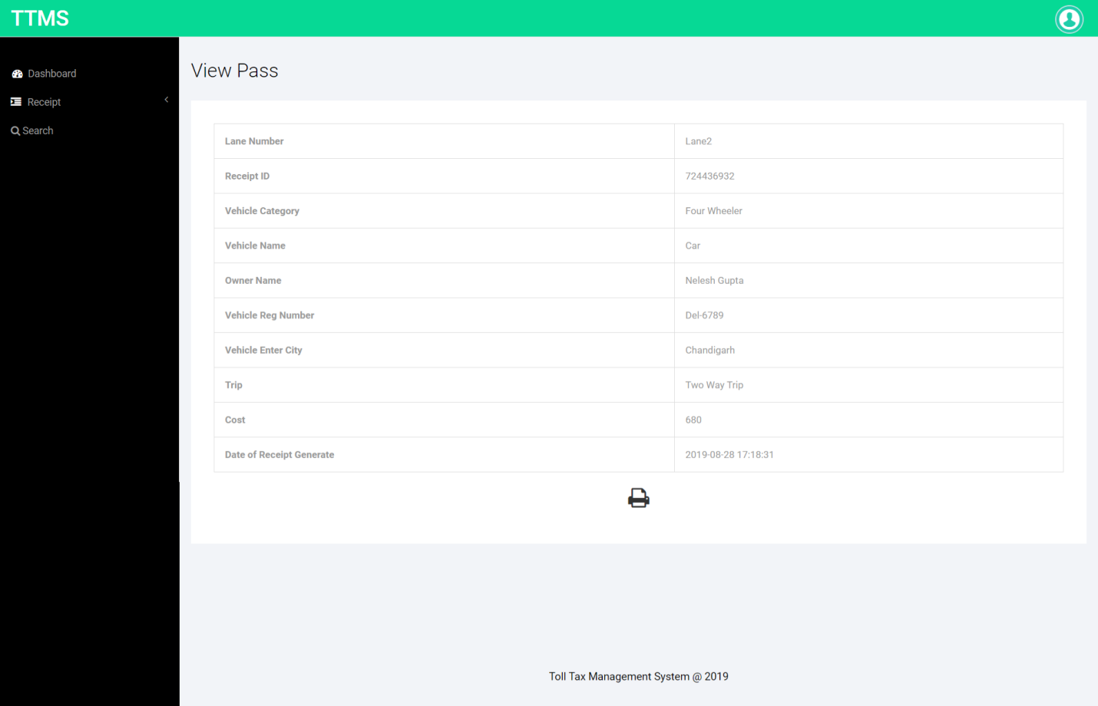

**Search Receipt**



**Staff Profile**

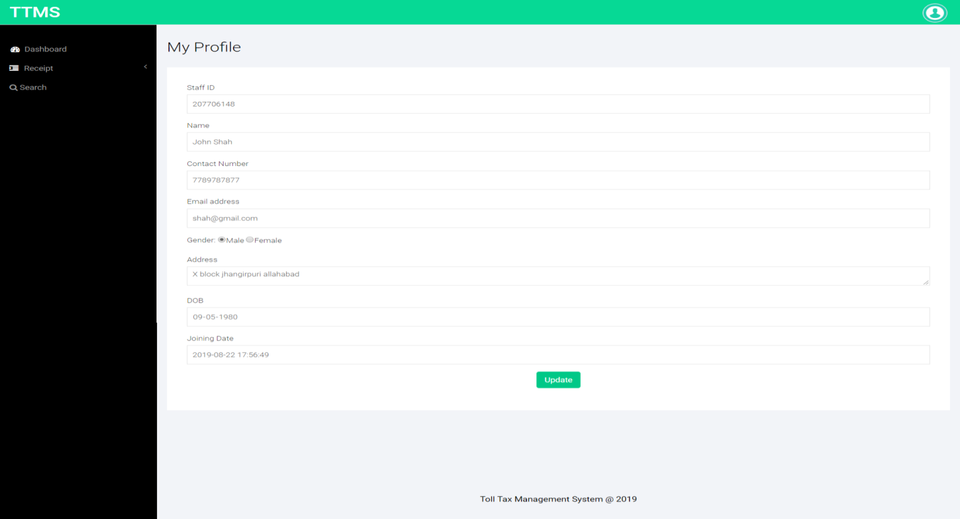

**Change Password**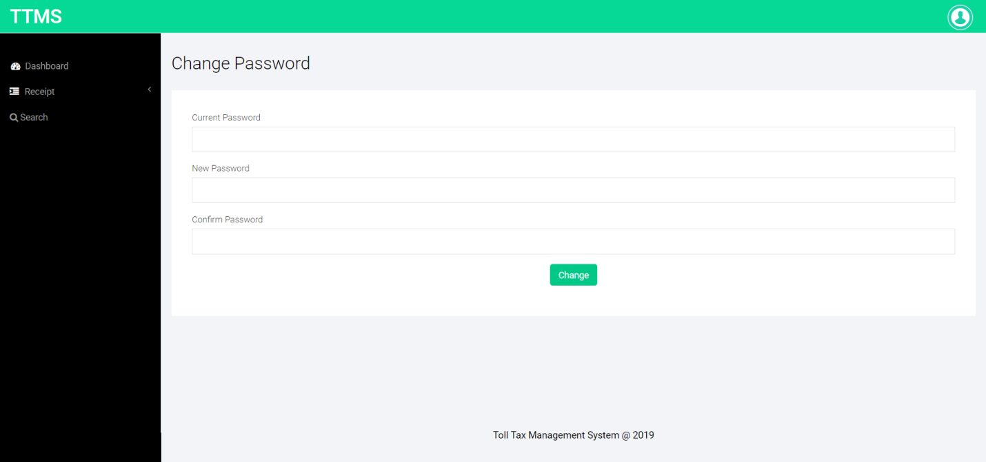

**Forgot Password**

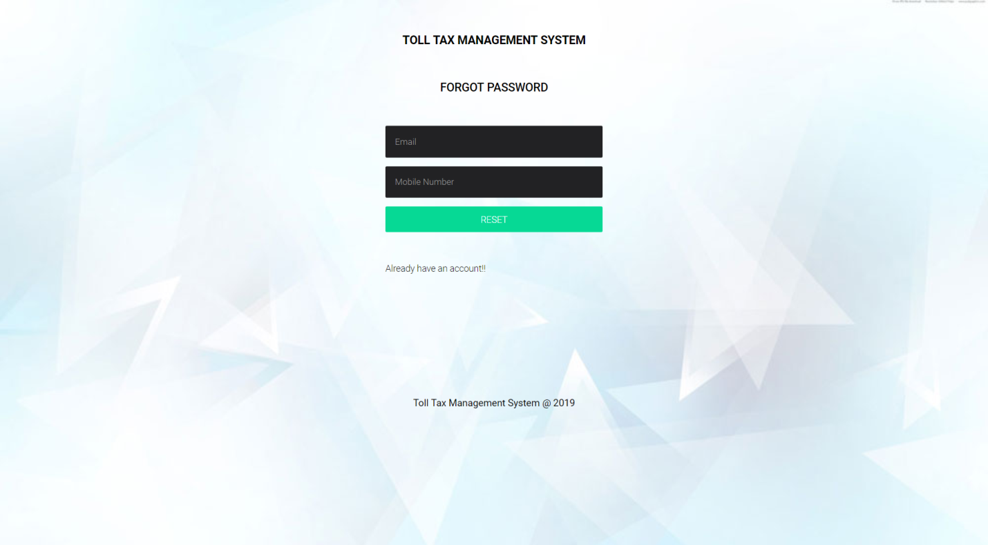

**Reset Password**



**CONCLUSION**

The project titled as **Toll Tax Management System** was deeply studied and analyzed to design the code and implement. It was done under the guidance of the experienced project guide. All the current requirements and possibilities have been taken care during the project time.

Toll Tax management system is used for daily operations in any organization to maintain or access toll related information for internal administration purposes.

**BIBLIOGRAPHY**

**For PHP**

* <https://www.w3schools.com/php/default.asp>
* <https://www.sitepoint.com/php/>
* <https://www.php.net/>

**For MySQL**

* <https://www.mysql.com/>
* [http://www.mysqltutorial.org](http://www.mysqltutorial.org/)

**For XAMPP**

* <https://www.apachefriends.org/download.html>